NBC Christmas meal

Thursday 14th December, 6pm
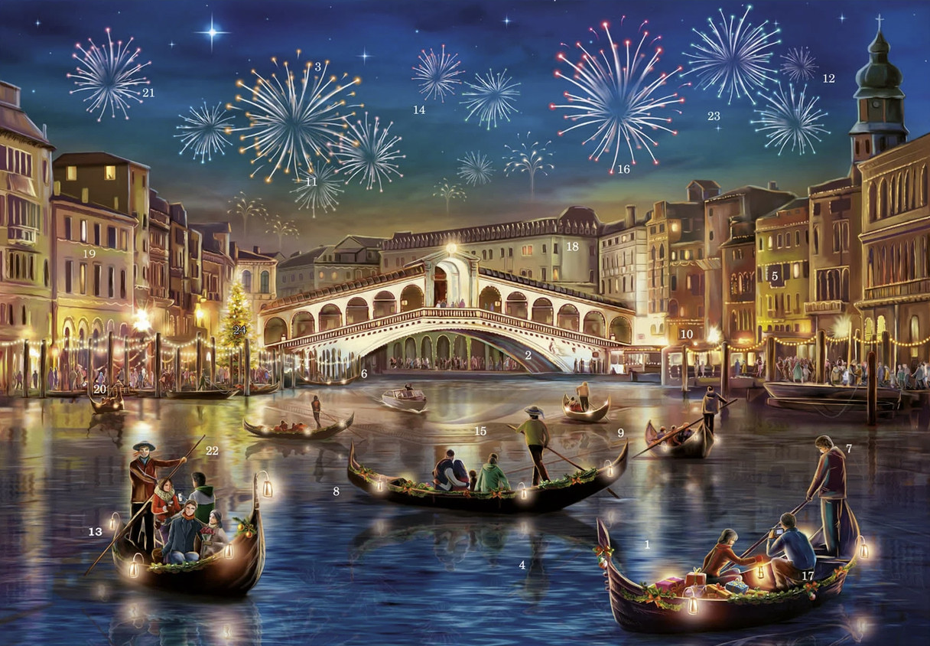
Chef: Derw Robertson-Jacobs
Four courses & welcome drink £35pp
Join us for a festive Christmas feast at Newport boat club where you will be transported to the shimmering canals & waterways of Venice. Derw will take you through some of his favourite Veneto delicacies he encountered on his trip in 2022.

On arrival, toast a hard days work on the gondolas with an Ombra
(small glass) of spritz and a selection of Cichetti (pronounced Che-ket-ee);
the Italian answers to canapés. Sample the deep red chicory (radicchio di Trevisio), made famous by Northern Italy and expertly grown by Adam of Awen Organics in Nevern. Enjoy Derw’s take on the traditional Christmas meal combining local Welsh ingredients with an Italian twist.

Menu
Aperitivo: 6pm
Spritz & *Cichetti
Primo (first course): 7pm
Raddicco* w. walnuts, pearl las & pomegranate

Secondo (second course)
Porchetta* or Celeriac wellington (V)
w. Polenta crusted potatoes & cavallo nero

Dolce (Dessert) - Tiramisu semifreddo

